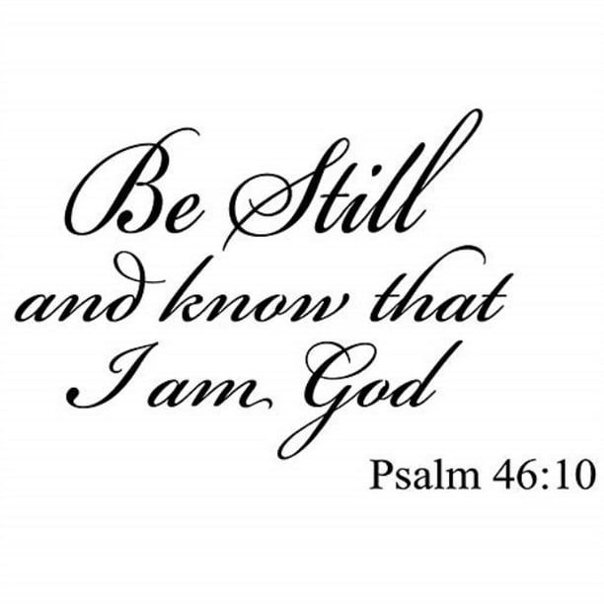

Saint Luke’s Church (Episcopal)
85 Greenway South, Forest Hills, NY 11375
(718) 268-6021 office@stlukesforesthills.org
www.stlukesforesthills.org
Mother Broderick, Interim Rector
(516) 298-7881 priest@stlukesforesthills.org

CHRIST THE KING/THE LAST SUNDAY AFTER PENTECOST
November 20th, 2022
11:00AM

HOLY EUCHARIST
Prelude Johann Sebastian Bach
Aria in D Minor

The Liturgy of the Word
* Entrance Hymn 460 Hyfrydol
* Acclamation Prayer Book p. 355
* The Collect for Purity
* Glory to God S278 William Mathias
* The Collect of the Day
The Lesson Jeremiah 23:1-6
Psalm 46
The Epistle Colossians 1:11-20
* Gospel Acclamation
Alleluia (sung by cantor, repeated by all)

Verse (cantor only):
Your love, O Lord, will I sing;
From age to age my mouth will proclaim your faithfulness.
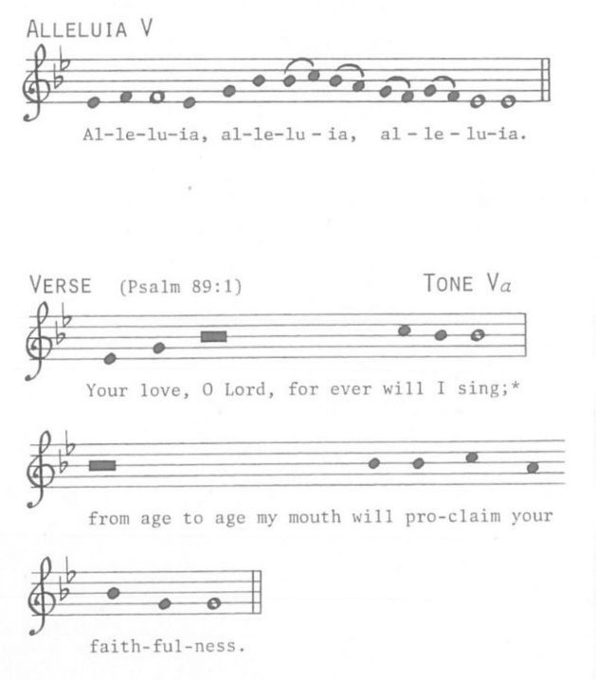
* Stand
* The Holy Gospel Luke 23:33-43
The Sermon Mother Broderick
* The Nicene Creed p. 358
* The Prayers of the People, Form VI p. 392
+ The Confession of Sin p. 360
* The Peace

The Holy Communion

* Offertory Anthem H. Purcell

Glory and worship are before him,
Pow’r and honor are in his sanctuary.
‘Tis he that hath made the round world so sure
that it cannot be moved;
Know ye that he shall judge the people righteously.

* Offertory Hymn 483 St. Magnus
* The Great Thanksgiving (A) p. 361
* Sanctus S128 W. Mathias
(sung first by choir, then repeated by all)
* Eucharistic Prayer p. 362

* The Lord’s Prayer p. 364

* Agnus Dei S165 W. Mathias

* Communion Hymn 458 vv 1-4 Love Unknown
* Postcommunion Prayer p. 366
* The Blessing
* Dismissal Hymn 494 Diademata
* The Dismissal
Postlude Alexander Reinagle
Allegro in B-flat Major

All Music Contained Herein is Reprinted and Streamed With Permission Under ONE LICENSE, License #A-740178.
All rights reserved.

Intercessions
Healing: Carol Alexander, Jamie Auriemma, Maria Barbanotti, Eleanor Blasucci, Graham Bobby, Gary Carldon,
Ann Chamberlain, Susan Civita, Yolande Dempster,
Luke Dinan, Joyce Egginton, Ann Fallon, Carlos Ferrara, Arlene Frank, Odi Gabbai, Vincent Gaccione, Barbara Glick, Christina Gonzalez, Cynthia Goodwin, Dolly Guinther, Michael Hubbard, Jim Kamprath, Elizabeth Kettlewell,
Kay Kripfgans, Thomas Kripfgans, Richard Kulinski,
Russell Kulinski, Miguel A. Lopez, Vicky Lowery,
Anton Marcial, Dominic Morrone, Pam Nardone,
Harry & Pansy Ogilvie, Nicole Palma, Jason Papamihalis, Brian Percival, Ketti & Bryan Petersen,
Lorraine Roach-Steele, Rachael Robinson, Suzanne Rolle, Yahra Roman, Flo Rosenberg, Allan Smith, Georgina Smith,
Lamont Springfield, Joanna Taylor, Rose Marie Thomas, Nona & Stephen Thompson, Hazel Vail, Shirley Vickers,
Jim Wade, Michael Willcocks

Deceased: Dawn Peterson

Birthdays: Carol Frye, Marianne Percival, Michael Karas, Jean Tessier

The Altar Flowers are given in memory of Zach Goodwin
by Jane Kettlewell.

The Sanctuary Lamp is given in honor of all of my loved ones
and my family by Myona Thomas.

All Saints Memorials: Bernardo Petruso, Barbara Drake,
Richie Cavallaro, Carmela Della Vecchia

Serving Today
8:00am
Lector – Jonathan Wallin
11:00am
Crucifer/Acolyte – Jean Tessier
Lector – Isabelle Smith
Ushers – Michael & Sherri Papamihalis
Bellringer – Br. Miłosz Kowal, FCC
Saint Luke’s Choir
Altar Guild – Jean Tessier
Church School – Emily Taylor and Francis Fallon
Hospitality Hour – Outreach Committee
William J. Stokes, Organist and Choir Director
The Reverend Joseph J. Occhiuto, FCC, Deacon
The Reverend Dr. Cecily P. Broderick y Guerra, Interim Rector

Lauren Butler, Parish Administrator

Parish Office Hours:
Monday – Friday, 9am – 2pm

718-268-6021 office@stlukesforesthills.org

Sunday Worship Hours:

8am and 11am [in-building/Zoom]

Meeting ID: 897 4444 1960 Passcode: STLWORSHIP

Church school at 10:45am on 2nd & 3rd Sundays
Nursery care available at 11am for children under 4
Priest:

Mother Broderick (interim)

516-298-7881 priest@stlukesforesthills.org

Church Calendar Week of November 20th
TODAY
Special thanks to Olivia Smith Grugan for stepping in as pianist and choir director today!

Hospitality Hour will be held in the narthex following the 11am liturgy. We will be hosting a Bake Sale at our Hospitality Hour on Sunday, November 20th to benefit Holy Apostles Soup Kitchen & Pantry.

Church School begins at 10:45am. Please gather downstairs in the orange classroom under the nave; the children will come upstairs to join their families for the Eucharist. This Sunday, the children will learn about the Jesse Tree, and about the importance of sharing God's love with our community, as they decorate ornaments for the tree. Since we expect a list of over 100 children, there will be a lot to make, so the project will continue during coffee hour. All parishioners are invited to participate!

The Gingerbread Players present the final performance of “The Merry Wives of Windsor” at 2:30pm. Suggested donation is $15 per person, or $12 each for groups of six or more. For ticket information, visit www.gingerbreadplayers.org.

WEDNESDAY THROUGH FRIDAY
The office will be closed. All bulletin notices must be in by 9am on Tuesday for printing that afternoon. The office will reopen on Monday.

THURSDAY (THANKSGIVING DAY)
Join us on Thursday, November 24th at 10am for a Holy Eucharist service with homily and organ.

ADVENT SUNDAY
Join us at 8am for a Holy Eucharist with homily and at 11am for a Choral Eucharist with sermon, choir and organ. (Don’t forget to take an ornament off the Jesse tree before you leave!)

Server Training – December 4th
There will be an usher/greeter training session with Mother Broderick at 9:30am on Sunday, December 4th between the two services. Those who are currently serving as well as those interested in serving are invited to attend.
Thursday, November 24th
Sunday, December 18th
Sunday, December 25th
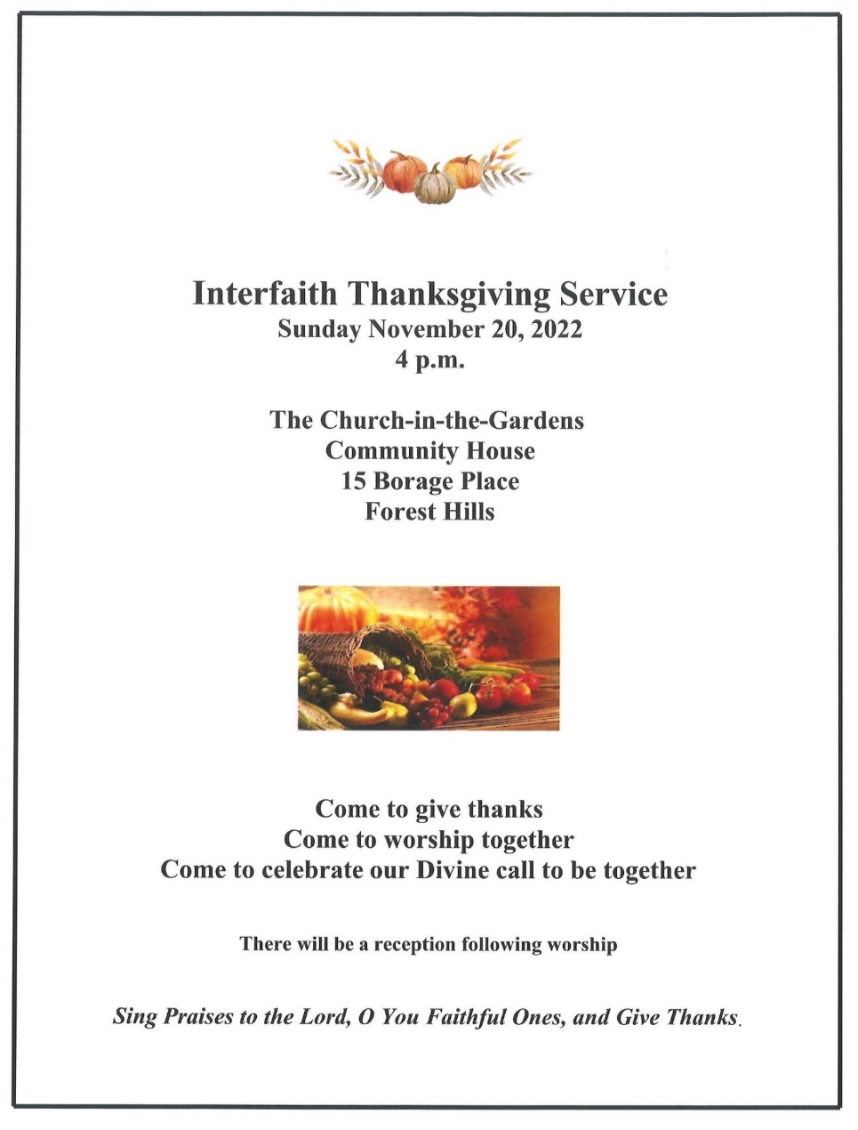
Saint Luke’s Church
List of Upcoming 10am Services

Thursday, November 24th
Sunday, December 18th
Sunday, December 25th

